**Lab-06 : Run a multi Pod containers**

**Step 1 :List all the pods**

# kubectl get pods

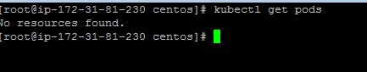

**Step 2 :Edit the configuration files of nginx-multi-label**

# vim nginx-multi-label.yaml

apiVersion: v1

kind: ReplicationController

metadata:

name: nginx-www

spec:

replicas: 3

selector:

app: nginx

template:

metadata:

name: nginx

labels:

app: nginx

spec:

containers:

- name: nginx

image: nginx

ports:

- containerPort: 80

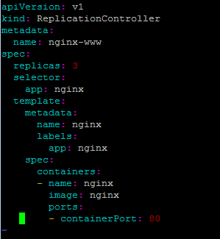

**Step 3 :List all the current running nodes(Now all Minion(Node)are ready for use)**

# kubectl get nodes

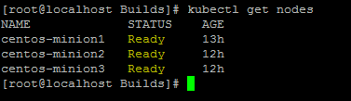

**Step 4 :Now create the nginx-multi-label container**

# kubectl create -f nginx-multi-label.yaml



**Step 5 :List all the current running pods(These 3 are just now created the pod with above configurations)**

# kubectl get pods

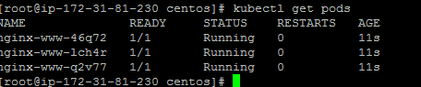

**Step 6 :Get the details about replicationcontroller**

# kubectl describe replicationcontroller

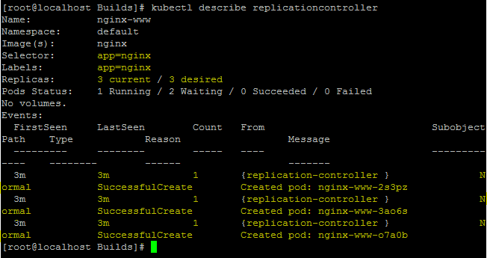

**Step 7 : Validate on which node a particual pod is running**

kubectl describe pods nginx-www-46q72

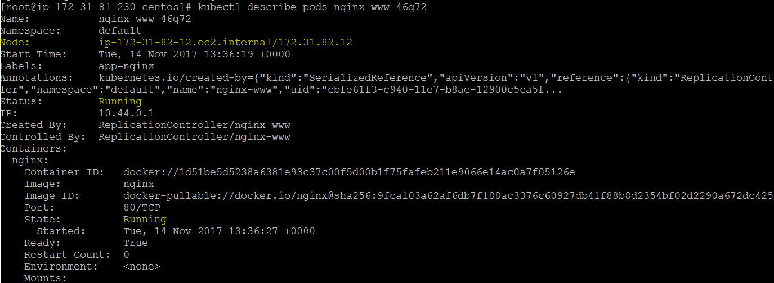

**Step 7 :Now list the running containers(On all the Minion(Node) )**

# docker ps | grep nginx



docker rm -f d61ad0b1438c

docker ps | grep nginx

